

ERASMUS+ Programme – Key Action 2: Strategic partnership
IENE 10 “PREPARING HEALTH AND SOCIAL CARE WORKERS TO WORK WITH SOCIALLY ASSISTIVE ARTIFICIALLY INTELLIGENT ROBOTS IN HEALTH AND SOCIAL CARE ENVIRONMENTS”
Agreement number: 2020-1-UK01-KA202-078802

Newsletter No. 3 March 2022
Introduction |  | The IENE 10 project aims to produce a European Transcultural Robotic Nursing (TRN) curriculum and learning materials that will be suitable for health and social care workers and  educators, not only within the partnership of this project but also internationally.  Τhe TRN curriculum is designed to promote culturally competent and compassionate transcultural care with the use of artificial intelligence and social robots. The TRN curriculum aspires to adapt to contemporary challenges and act as an enabler in the caring of those in need. The TNR curriculum also aims to increase knowledge on TRN and provide a comprehensive knowledge map about TRN.  In the last five months, IENE 10 partners developed Learning Units (LU), which will be uploaded to the selected MOOC (Massive Open Online Course) platform and provide the core learning activities that IENE 10 students will perform with the support of IENE 10 facilitators in Autumn 2022.  The developed LUs are different from each other, both concerning WHAT students will learn and the way HOW they will learn. All LUs provide relevant definitions and terms as well as links to the scientific articles and additional material that the student may want to explore. However, they also make use of a variety of online resources that can be, from time to time, videos, quizzes, chatbots, crosswords, etc.  The development of LUs was based on  - Intellectual Output 1.2, Transcultural Robotics Nursing (TRN) Curriculum Model  - Intellectual Output 2 Transcultural Robotics Nursing (TRN) Modules.  The MOOC platform that will be used for collaborative learning is APTEM, https://www.aptem.co.uk/. |           
Output 3  Development of Learning Tools |  | Below, you can see an example of learning activity taken from Learning Unit “Need for AI and robots.”  After reading the relevant definition and terms, as well as watching some short videos, students are asked to edit the comic below using the online tool “StoryboardThat”. The objective is to change the story in the bottom two panels depending on their view about the role robots might play in social assistance.  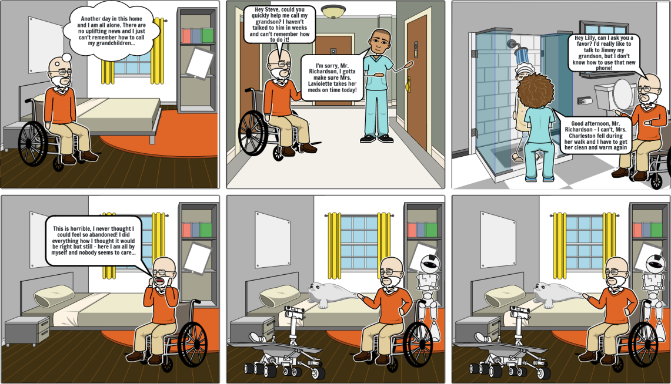  After performing all the required activities, students will be asked to upload their work to the online platform for collaborative learning, and finally to assess what they have learnt through quizzes or small games.  Each partner developed two or three LUs, which were revised by other partners, and then edited and merged to prepare the IENE 10 handbook.
Output 4  Set up the MOOC |  | Currently, partners are setting up the MOOC platform for collaborative learning by uploading all the learning material that have been produced so far. A meeting at Middlesex University, London will be held in September 2022 to train facilitators on how to use the MOOC platform .
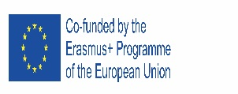  4rd Transnational meeting (online) |  | The main objective of the meeting was to share brief updates of partners’ work, to prepare for the face-to-face meeting in Genova on 2-3 March 2022.
5th Transnational meeting in Italy  (face to face) |  | The main topic of the meeting was the discussion about the LUs developed by partners in the previous months, and how they will be embedded into the APTEM MOOC platform for collaborative learning to be used by students and facilitators during the course.  Summarizing, the main objectives of the meeting were:  - To share updates of partners’ work  - To assess the quality of the Learning Units developed by partners and discuss possible updates or revisions  - To familiarize with the APTEM MOOC platform for collaborative learning and plan the training course for facilitators that will assist students  - To explore recruitment plans and piloting strategies  - To plan future publications to disseminate results of the scientific community, to the media, and the general public.  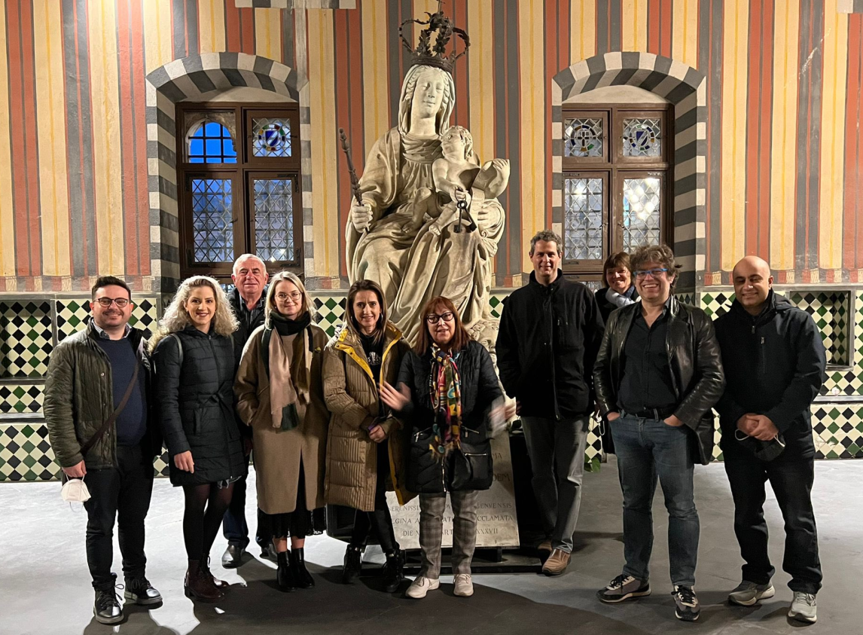
Next meeting |  | The next meeting will be in May 2022 in Dornbirn, Austria
This project has been funded with support from the European Commission. This publication reflects the views only of the author, and the Commission cannot be held responsible for any use which may be made of the information contained therein. |  |         

